ACS-2814: Applications of Database Systems
Assignment 3

Daljeet Singh, 3169763

Part A: Application Definition and Conceptual Model

Complete the application definition using the template below. You may remove the blue text which is serving as guidance and an example. You may also remove this highlighted note from your final submission.

A1. Application Definition [ 5 marks ]
Industry/ Type of Application | Big business: Bodyguard Provider Service
Problem Statement / Overview | People hire bodyguards for personal safety, asset protection, and secure event handling. Celebrities and public figures often need protection from fans and paparazzi, while executives require security to avoid threats or corporate espionage. Wealthy individuals hire bodyguards to prevent robberies or kidnappings, and events like weddings or corporate gatherings use them to control access and protect high-profile guests.  Witnesses in legal cases may need security against intimidation, and journalists reporting in conflict zones often require protection. High-risk travelers going to unstable regions rely on bodyguards for safety. Those facing stalking or domestic violence may hire bodyguards temporarily for daily routines to prevent attacks.
Major Entities | User: Person that hires the bodyguard  - Contains the information about the user.  Payment: User provides payments.  - Payment Number  - Credit card Number  Account: User owns the account  - Account Number  - UserID  Location : Address where bodyguards works.  - State  - Country  - Postal Code  Schedule : Provides the details about the shifts.  - Start and end time  Service: Represents the information about the service.  - Service type  - Descriptoin  Bodyguard: People hire bodyguards.  - First and last name  - BodyguardID  - Base Rate

A2. Logical Data Model [ 10 marks ]

Paste or insert an image of your LucidChart logical data model below.

<< insert image of logical data model here >>
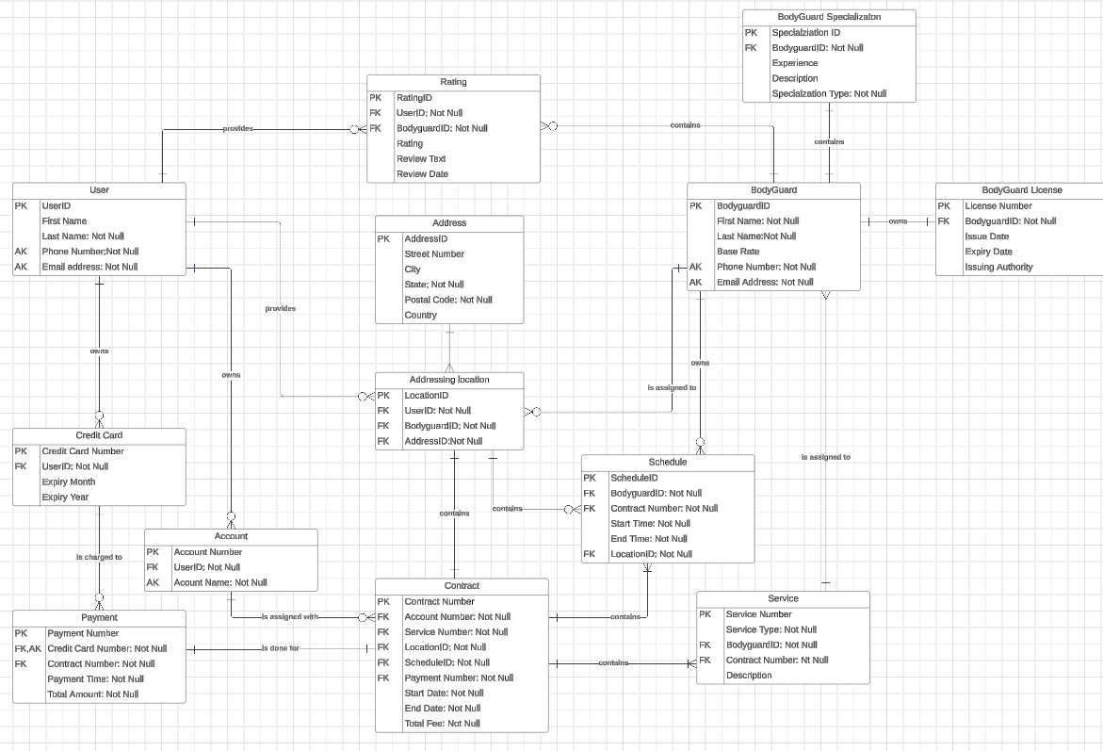

B1. Define all the Tables and Relationships [ 5 marks ]

Screenshot 1: Include an image of your completed Database Relationship Diagram from MS Access
<< insert screenshot here>>
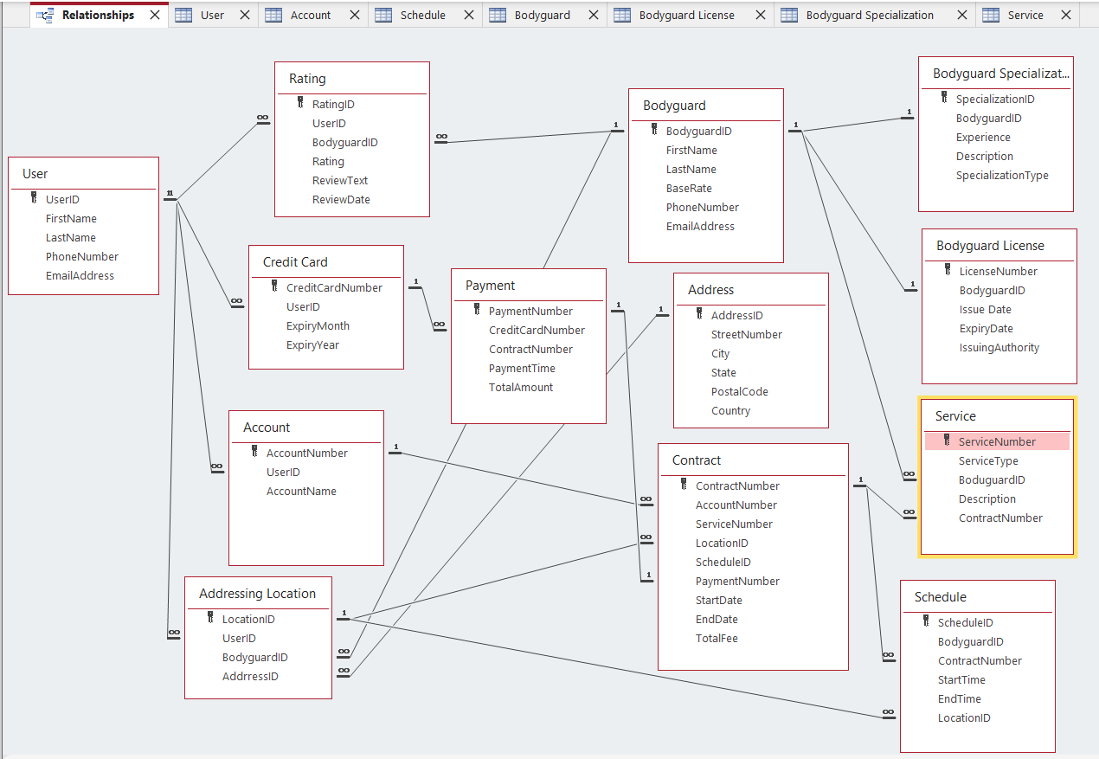

Screenshot 2: Include a screenshot of your Table Design highlighting/showing the implementation of the alternate key. This can be a screenshot of either the table design editor (showing the column implemented as the AK) or the indexes window with the alternate key selected.

<< insert screenshot here>>
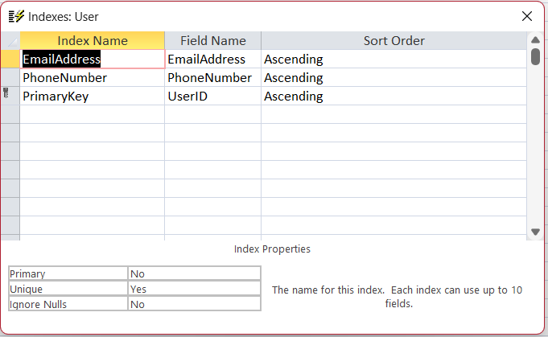

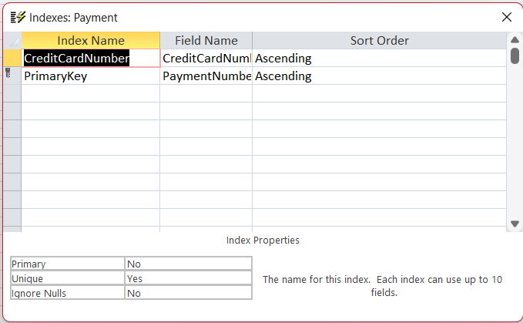

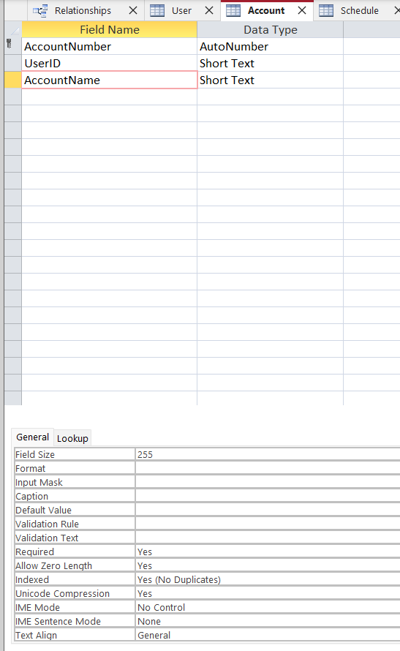

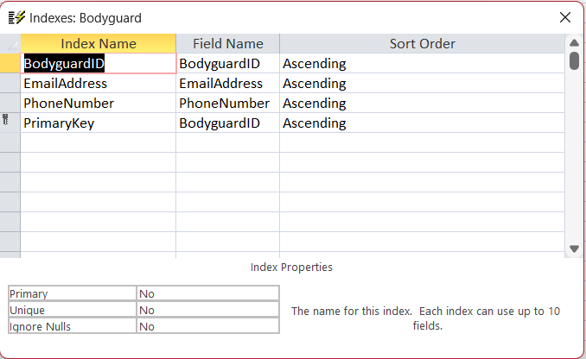

B2. Create Sample Data in Each of the Tables You’ve Defined [ 2 marks ]

Data Samples Screenshots: Include a Screenshot of Sample Data for Each of Your Tables in MS Access Below. Partial screenshots (showing some but not necessarily all of the columns) are acceptable).
<< insert screenshots here>>

